**Arduino Integrated Amateur Station Accessories**

**By**

**WD9GYM Marty Boroff**

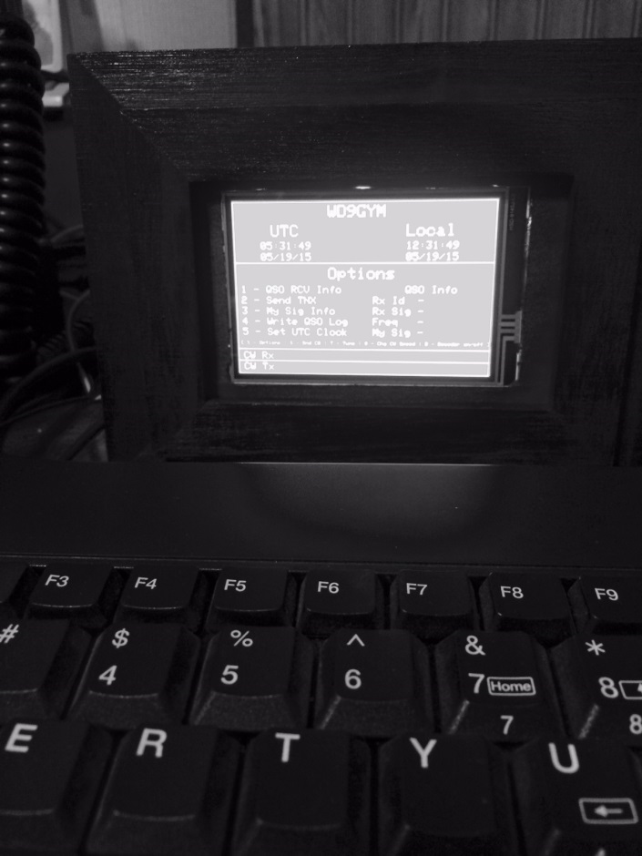

My integrated accessories consist of a PS/2 Keyboard CW encoder, a Station Clock, a Morse Code Decoder and a QSO logger. The project uses an ATmega2560 for the main processor and an Arduino Nano to perform Morse code decoding. The inspiration for this project was “Arduino Projects for Amateur Radio” by Jack Purdum and Dennis Kidder. The code for the PS/2 CW encoder was taken from the source code provided by this book. The chapter on a Station Timer spawned ideas for the Station Clock. The chapter on a Morse code decoder lead me to the design and coding of my version (with some help from W8TEE Jack Purdum). The QSO logger was completely my idea. The foundation for coding the TFT, SD card and RTC (Real Time Clock) came from examples in the libraries provided for these devices.

**Parts**

|  |  |
| --- | --- |
|  | The case for the project was a Box Frame. Additional hardware parts of the case include a power jack, stereo phone jack, mono phone, board clip and PS/2 keyboard jack. |
|  | Components consist of an ATmega2560 and prototype board, some hookup wire, a few resistors, an LED, and an Arduino Nano. A complete list of parts is listed further down in this write-up. |

**Construction**

**Point to point wiring**

1. Pins 2 and 4 of the 4N26 connected to ground.
2. Pin 1 of the 4n26 connected to 470 Ohm resistor

470 Ohm resistor connected to pin 28 of ATmega2560

1. Pin 5 of 4N26 connected to tip of key jack.
2. Pin A2 of Nano connect to tip of Headphone jack
3. Pin 13 of Nano connect to 470 Ohm resistor.

470 Ohm resistor connected to + side of LED.

Negative side of LED connected to ground

1. TX of Nano connected to RX3 (pin D14) of ATmega2560
2. RX of Nano connected to TX3 (pin D15) of ATmega2560
3. Keyboard clk connected to pin 19 of ATmega2560
4. Keyboard data connected to pin 22 of ATmega2560
5. SDA of RTC connected to pin 23 of ATmega2560
6. SCL of RTC connected to pin 25 of ATmega2560
7. CLK of SD connected to pin 52 of ATmega2560
8. MISO of SD connected to pin 50 of ATmega2560
9. MOSI of SD connected to pin 51 of ATmega2560
10. CS of TFT connected to pin 31 of ATmega2560
11. DC of TFT connected to pin 29 of ATmega2560
12. RST of TFT connected to pin 8 of ATmega2560
13. CLK of TFT to pin 52 of ATmega2560
14. MISO of TFT to pin 50 of ATmega2560
15. MOSI of TFT to pin 51 of ATmega2560
16. All Vcc of RTC, SD, TFT, Nano, and 5V power supply to common points
17. All Gnd of devices to common points

|  |  |
| --- | --- |
|  | Begin by placing the Arduino Nano and a six pin IC socket on the prototype board to determine the best placement. Wires will be connected between solder holes on the edges of the prototype where there are connections to pins on the ATmega260 the Arduino Nano and the IC socket. There will also be wires connecting components to separate header pins for connections to header pins for the power supply, headphone jack, key jack and headphone jack. |
|  | This is an example of a partially wired board. Follow the schematic when wiring the board. This particular board has some strips that allow several connections to be wired together using single holes. Most of the connections will require wrapping the end of a component around a pin. For this reason do not clip the leads of a wire or resistor until you a sure it is not joined to another component. |

|  |  |
| --- | --- |
|  | The photo box comes with a small piece of thin plywood which you will cut out the center to form a mask for mounting the TFT.  The ATmega2560 is mounted to a plastic clip.  Appropriate holes are drilled in the back of the photo box to accommodate all of the jacks. |

**Parts List**

|  |  |
| --- | --- |
| ATmega2560 | Purchased on eBay |
| Arduino Nano | Purchased on eBay  [Mini USB Nano V3.0 ATmega328P CH340G 5V 16M Micro-controller board For Arduino](http://www.ebay.com/itm/111654763655?_trksid=p2060353.m2749.l2649&ssPageName=STRK%3AMEBIDX%3AIT)  Be sure you get the one with the Mini USB to facilitate programming. |
| ATmega2560 Prototype Board | Purchased on eBay |
| 4N26 Optoisolator | Mouser Electronics |
| 2 – 470 ¼ watt resistors | Mouser Electronics |
| PS/2 Keyboard Panel Mount connector | Mouser Electronics |
| 1/8 “ Stereo jack | Mouser Electronics |
| 1/8” Mono jack | Mouser Electronics |
| Micro SD Storage Board Mciro SD TF Card Memory Shield Module SPI For Arduino | Purchased on eBay |
| DS3231 AT24C32 IIC Precision RTC Real Time Clock Memory Module For Arduino | Purchased on eBay |
| 3.5” TFT | Adfruit  https://www.adafruit.com/product/2050 |
| Photo Box Single – item no. 9756131 | Jo Ann Fabrics  http://www.joann.com/box-frame-single/9756131.html |
| Hookup Wire | Purchased on eBay |
| 5 Pcs 5.5mm X 2.1mm DC Power Jack Guitar Pedal PCB Panel mounting PC Charger DIY | Purchased on eBay |
| LED | Purchased on eBay |
| Schmartboard female/female 12” jumpers | Schmartboard  http://www.schmartboard.com/index.asp?page=products_jumpers&id=855 |

**Program Sketches**

**Morse Code Decoder**

Source for the original code can be found <http://www.skovholm.com/cwdecoder>. The unique offering for this decoder is the use of the Goertzel formula to filter tones for a single frequency without the use of active components. All filtering is done with software. During development of the integration I was able to determine that this code is processor intensive. It really works best if it is not interrupted by other code routines. This is why the code runs on an Arduino Nano. In order to display the decoded character the sketch outputs the character to the serial port. The serial port on the Nano is wired to the third serial ports on the ATmega3560. When the ATmega2560 is instructed to decode it raises pin 28 HIGH and read on pin 4 of the Nano. The LED connected to pin 13 on the Nano will flash when you tune the tone of the receiving signal to 700 Hz in your headphones. The headphone jack of your receiver is shared with your headphones and pin A2 of the Nano. When you wire the boards please ensure all ground connections are connected together including the ground from your headphone jack.

///////////////////////////////////////////////////////////////////////

// CW Decoder made by Hjalmar Skovholm Hansen OZ1JHM VER 1.01 //

// Feel free to change, copy or what ever you like but respect //

// that license is http://www.gnu.org/copyleft/gpl.html //

// Discuss and give great ideas on //

// https://groups.yahoo.com/neo/groups/oz1jhm/conversations/messages //

///////////////////////////////////////////////////////////////////////

///////////////////////////////////////////////////////////////////////////

// Read more here http://en.wikipedia.org/wiki/Goertzel_algorithm //

// if you want to know about FFT the http://www.dspguide.com/pdfbook.htm //

///////////////////////////////////////////////////////////////////////////

**When uploading the Nano be sure the serial leads are not connected. If you have the board wired, remove the shield before uploading**

**Integrated Accessories ATmega2560**

The integrated accessories provided are:

Display local and UTC time

Menu processing for gathering information on a QSO, writing the QSO info to the micro SD card, setting the RTC clock, keying your rig for 3 seconds for tuning and turning the Morse code decoding on or off.

1 - QSO RCV Info % - Options

2 - Send TNX S - Snd CQ

3 - My Sig Info T - Tune

4 - Write QSO Log # - Chg CW Speed (< lowers speed > increase speed)

5 - Set UTC Clock D - Decoder on/off

Displaying received or sent Morse code is near the bottom of the display.

% enters menu mode ESC exits menu if in menu mode

ESC not in menu mode clears the keyboard buffer

**Libraries**

PS/2 Keyboard <http://www.pjrc.com/teensy/td_libs_PS2Keyboard.html>  
RTC <https://github.com/JChristensen/DS3232RTC>  
TFT See Adafruit tutorial on 3.5” tft  
 <https://learn.adafruit.com/adafruit-3-5-color-320x480-tft-touchscreen-breakout>

**Schematic**

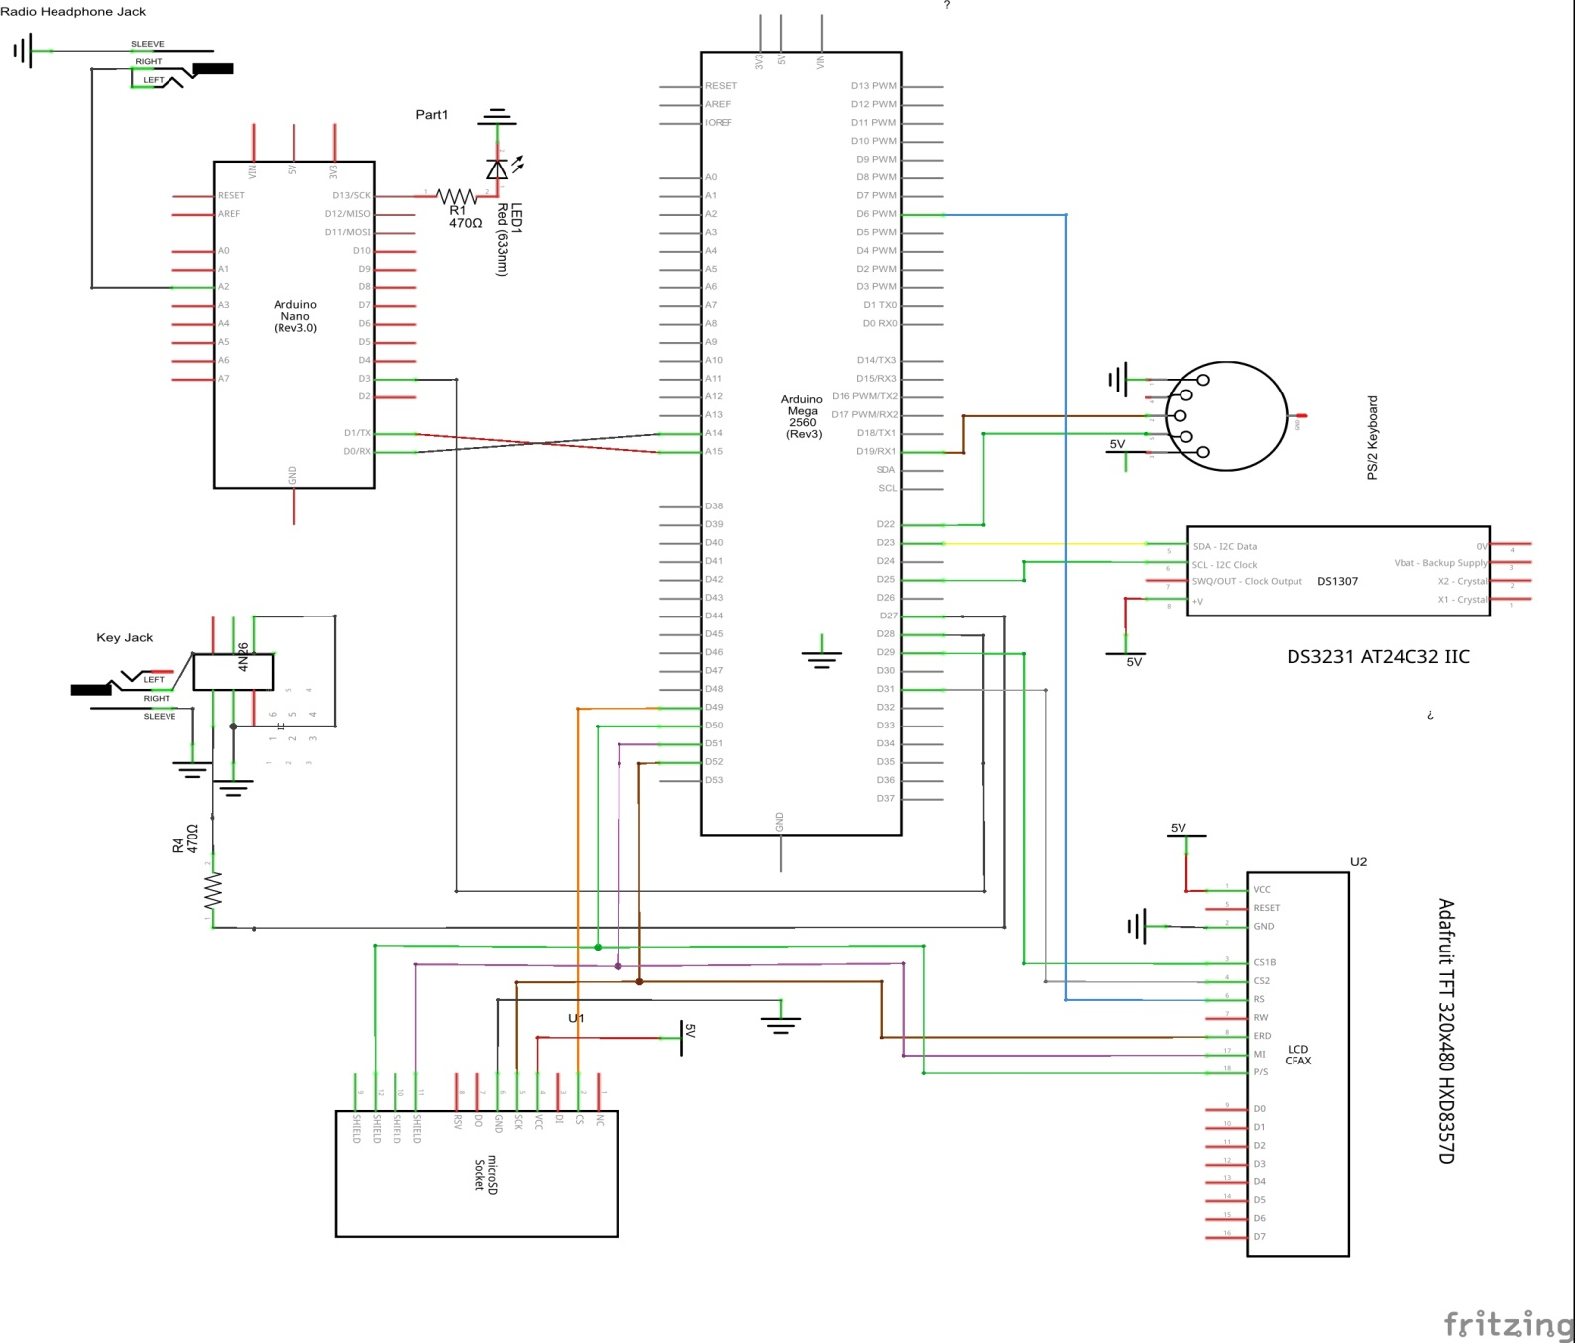schematic